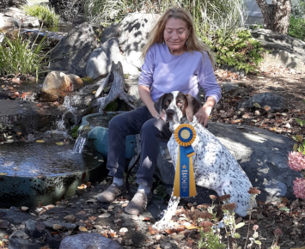Bonnie, “**Rose Mountain’s Bonnie Lass** BN CD RA SWN CGCA TKN (CDSP – CD-C) (NACSW – NW2 L1I L1C, UKC – NN)

* On July 21 at FDTC of Northern NJ’s AKC Scent Work trial she earned her Exterior Novice **SEN** title which earned her the overall SWN title
* At the Ramapo Kennel Club’s AKC Rally trial on Oct. 12 Bonnie earned her **Advanced** title with a 97.
* At FDTC of Northern NJ’s AKC Obedience trial on Oct. 20 she earned her **CD**, Companion Dog title with a 3rd place.
* On December 7 at Your Dog’s Place’s NACSW trial in Hawley, PA, Bonnie earned her **NW2** title! We were thrilled with that one, 5 searches, 2 interior, 1 container search with distractions, 1 vehicle and 1 exterior. It was only her 2nd try so made it even more special.